Experiment 3

AIM: Write a program which defines a class Bank with member functions deposit, withdraw, compound interest, and getBalance. It should have a constructor to initialize balance and rate of interest. Implement a menu driven program to use these features.

Theory:

A constructor is a member function of a class which initializes objects of a class. Destructor is a member function which destructs or deletes an object. There are 3 types of access modifiers available in C++:

- Public: All the class members declared under public will be available to everyone.

- Private: The class members declared as private can be accessed only by the functions inside the class.
- Protected

Code:


#include < iostream >
#include < cmath >

using namespace std;
class Bank {
float balance, rate;
float getBalance() {
return balance;
}
float getRate() {

return rate;
}
float deposit(float m) {
balance += m;
return balance;
}
float withdraw(float m) {
if (balance >= m) balance -= m;
return balance;
}
float compound(int t) {

return balance * pow(1 + rate / 100, t);
}
public: Bank() {
cout << "Enter balance and rate:";
cin >> balance >> rate;
}~Bank() {
cout << "I am destroyed." << endl;
}
int menu() {
int op;
cout << "1 - Deposit" << endl;

cout << "2 - Withdraw" << endl;

cout << "3 - Compound interest" << endl; cout << "4 - Get balance" << endl; cout << "5 - Exit" << endl; cin >> op;

switch (op) {
float money, time;


case 1:
cout << "Enter amount to deposit: ";

cin >> money;
cout << "Current balance: " << deposit(money) << endl;

break;

case 2:

cout << "Enter amount to withdraw: "; cin >> money;
cout << "Current balance: " << withdraw(money) << endl;

break;

case 3:

cout << "Enter time: ";
cin >> time;
cout << "Compound interest: " << compound(time) << endl
;
break;
case 4:
cout << "Current balance: " << getBalance() << endl; break;

}
return op;
}
};
int main() {

Bank dj;
while (dj.menu() != 5) {}
return 0;
}

Output:
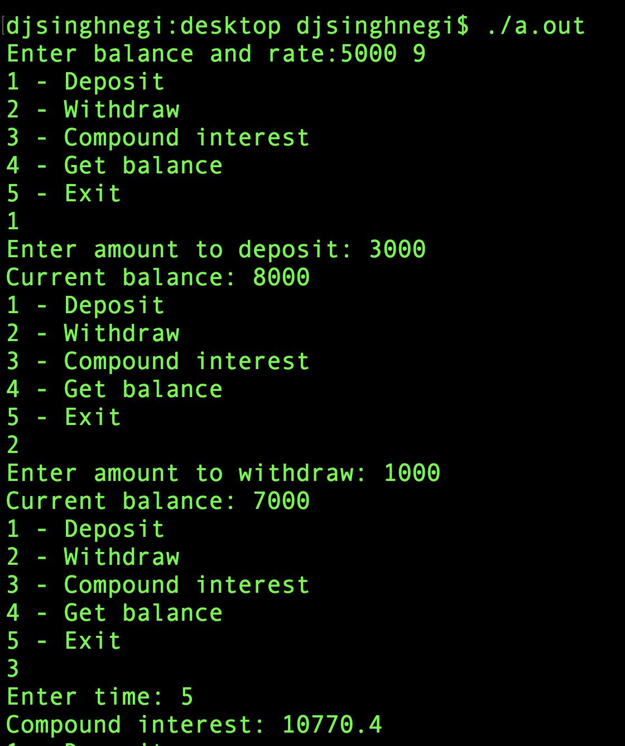
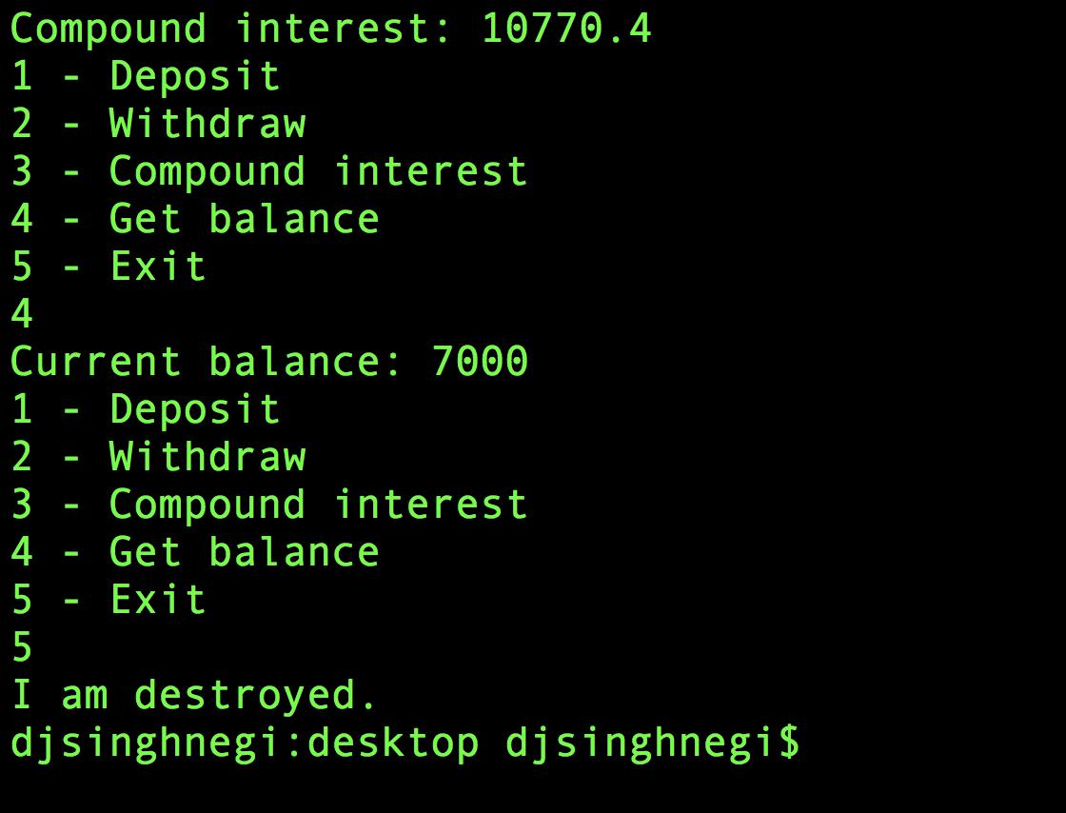

Discussion:

The class bank has 5 private methods: getBalance: to get the balance, getRate: to get the rate of interest, deposit: to deposit money and it returns the resultant balance, withdraw: to withdraw money and it returns the resultant balance, and compound to calculate compound interest. The constructor initializes the balance and the rate of interest. The menu method starts a menu driven program on the instance aneesh.

